COURSE CODE/TITLE: | CPE 010 |  | SECTION: | CPE21S3
DATE PERFORMED: | 9/1/26 |  | DATE SUBMITTED: | 9/1/26
NAME: | Ralf Nicolo B. Abello |  | INSTRUCTOR: | Engr. Jimlord Quejado

ACTIVITY NO. 7.2 | Algorithm Complexity
1. PROCEDURE OUTPUT
1. Finding an Element
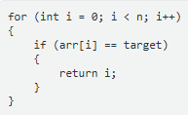 | 1. Best-Case Time Complexity - O(1)  2. Worst-Case Time Complexity - O(n)  3. Brief Explanation - I get O(1) when target is at arr[0], and O(n) when it's at the end or missing, since I'd scan the whole array.

2. Printing All Elements
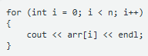 | 1. Best-Case Time Complexity - O(n)  2. Worst-Case Time Complexity - O(n)  3. Brief Explanation - The loop always runs n times regardless of input values, so both cases are the same.

3. Nested Loops
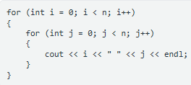 | 1. Best-Case Time Complexity - O(n^2)  2. Worst-Case Time Complexity - O(n^2)  3. Brief Explanation - Both loops always run fully to n with no early exit(not meeting the condition of the outer loop), so I get n x n operations every time.

4. Conditional Processing
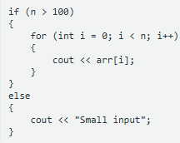 | 1. Best-Case Time Complexity - O(1)  2. Worst-Case Time Complexity - O(n)  3. Brief Explanation - If n <= 100 I just print a constant message, but if n > 100 I loop through all n elements.

5. Fixed Inner Loop
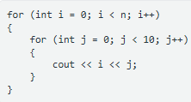 | 1. Best-Case Time Complexity - O(n)  2. Worst-Case Time Complexity - O(n)  3. Brief Explanation - The inner loop always runs a constant 10 times, so it's dropped in Big-O, leaving just the outer n iterations.

6. Two Consecutive Loops
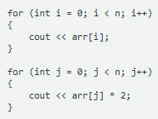 | 1. Best-Case Time Complexity - O(n)  2. Worst-Case Time Complexity - O(n)  3. Brief Explanation - I add two separate O(n) loops together, and since constants don't matter, it simplifies to O(n).

7. Dividing by Two
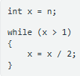 | 1. Best-Case Time Complexity - O(log n)  2. Worst-Case Time Complexity - O(log n)  3. Brief Explanation - I'm halving x each iteration until it drops to 1, which always takes log n steps regardless of input.

8. Nested Loop With Different Limits
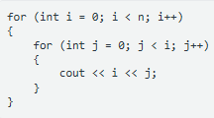 | 1. Best-Case Time Complexity - O(n^2)  2. Worst-Case Time Complexity - O(n^2)  3. Brief Explanation - The inner loop runs i times for each i, so when I add 1+2+...+n it still gives me O(n^2).

9. Early Termination
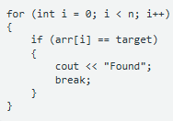 | 1. Best-Case Time Complexity - O(1)  2. Worst-Case Time Complexity - O(n)  3. Brief Explanation - I get O(1) if target is found at arr[0] and breaks immediately, but O(n) if it's found last or not at all.

10. Two-Level Search
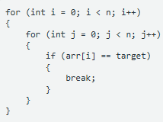 | 1. Best-Case Time Complexity - O(n)  2. Worst-Case Time Complexity - O(n^2)  3. Brief Explanation - The break only exits the inner loop, so if arr[i] == target is true on the first outer iteration, the inner loop breaks fast each time giving O(n), but if it's never true I run the full n x n

11. Linear Loop With Logarithmic Inner Work
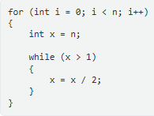 | 1. Best-Case Time Complexity - O(n log n)  2. Worst-Case Time Complexity - O(n log n)  3. Brief Explanation - The inner while loop is always O(log n) with no shortcuts, and it runs once per outer iteration, so I multiply by n.

12. Conditional Nested Loop
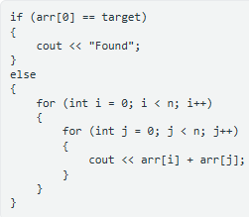 | 1. Best-Case Time Complexity - O(1)  2. Worst-Case Time Complexity - O(n^2)  3. Brief Explanation - If arr[0] == target I skip straight to a constant-time print, but otherwise I fall into the full nested loop of O(n^2).

13. Finding the Maximum
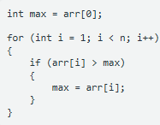 | 1. Best-Case Time Complexity - O(n)  2. Worst-Case Time Complexity - O(n)  3. Brief Explanation - I have to check every element from index 1 to n-1 regardless of the values, since there's no early exit.

14. Three Nested Loops
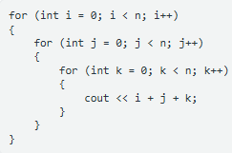 | 1. Best-Case Time Complexity - O(n^3)  2. Worst-Case Time Complexity - O(n^3)  3. Brief Explanation - All three loops always run fully to n independently, giving me n x n x n operations every time.

15. Comprehensive Analysis
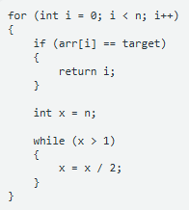 | 1. Best-Case Time Complexity - O(1)  2. Worst-Case Time Complexity - O(n log n)  3. Brief Explanation - I get O(1) if arr[0] == target and I return immediately, but if the target is never found, I run the O(log n) while loop on every one of the n iterations.

2. ANSWERS TO SUPPLEMENTAL ACTIVITY
Copy and paste the questions from the lab and include your answers after.

3. ARTIFICIAL INTELLIGENCE (AI) USE DISCLOSURE STATEMENT
I hereby declare that artificial intelligence (AI) tools were used, if applicable, in the preparation of this academic work. The following indicates the nature and extent of AI assistance:

Tools Used:
Examples: ChatGPT, Microsoft Copilot, Grammarly, QuillBot, etc.

Purpose of Use:
Examples: grammar correction, idea generation, formatting, summarization, code assistance, explanation of concepts, etc.

Extent of Use:
Explain how AI was used and confirm that it did not replace original thinking, analysis, authorship, or completion of the required work.

By submitting this activity, I affirm that my use of AI complies with T.I.P.’s AI usage policy and does not exceed the permitted limits for similarity, automated content generation, or academic assistance.

I understand that any false, incomplete, or misleading disclosure may be subject to investigation in accordance with due process and may result in sanctions for violation of existing T.I.P. policies.

Lab activities, templates, and related instructional materials shall not be reuploaded, reproduced, distributed, or shared with external organizations or third parties without the prior express written permission of the Technological Institute of the Philippines.

